
MOTSWEDING EVENT MANAGEMENT
Network Infrastructure Design
Milestone 1 — Client Design Review
Project Information | Details
Organisation | Motsweding Event Management (Potchefstroom)
Industry | Entertainment
Project ID | CMPG325-2026-123
Client ID | CLI-123
Student | SEKO, OFENTSE
Student Number | 54461626
Assigned Challenge | Router-on-a-Stick (sub-interface Inter-VLAN routing)
Addressing Block | 10.48.0.0/16
Design Constraint | Point-of-sale systems must stay online even if the office LAN fails.
Change Request | CR1 — 8 additional staff in one department without redesigning the network.
GitHub Repository | github.com/Ofentse2212/motsweding-network-infrastructure
Prepared for Client Design Review

1. Milestone 1 Submission Scope
This document consolidates the five deliverables specified for Milestone 1. Client requirements are set out in Section 2, the physical topology follows in Section 3 with the full diagram presented on its own landscape page as Figure 1, the logical topology is covered in Section 4 with its diagram presented on its own landscape page as Figure 2, the IP addressing plan is detailed in Section 5, and the initial GitHub repository is described in Section 6.
The design is based on the assigned project brief for Motsweding Event Management (Potchefstroom), issued by the NWU Department of Computer Science and Information Systems under Project ID CMPG325-2026-123. The implementation will be developed and simulated in Cisco Packet Tracer using the assigned 10.48.0.0/16 addressing block. Throughout the project, the design must demonstrate Router-on-a-Stick inter-VLAN routing, POS resilience if the office LAN fails, and accommodation of Change Request CR1 (eight additional staff in one department) without redesigning the network.

2. Client Requirements
The project brief assigns Motsweding Event Management (Potchefstroom), an entertainment-industry client, as the fixed scenario for this project; the organisation and industry may not be substituted for another. The client's addressing block, 10.48.0.0/16, forms the basis of the entire IPv4 addressing plan developed in Section 5. Beyond addressing, the brief requires the design to provide appropriate connectivity and network services for the assigned scenario, to use an appropriate topology and device arrangement, and to implement that topology in Cisco Packet Tracer using the necessary routers, switches, and end devices.
The assigned technical challenge is Router-on-a-Stick, using router sub-interfaces to perform inter-VLAN routing; the brief classifies this challenge as Advanced for CMPG 325, and the final submission must configure, verify, and demonstrate it, with the student prepared to explain what was configured, why it is appropriate, and how it was verified. Alongside the technical challenge, the brief sets a fixed design constraint — point-of-sale systems must stay online even if the office LAN fails — and a change request, CR1, under which the client signs eight additional staff into one department and the network must absorb that growth without being redesigned.
Testing requirements round out the brief: the final solution must demonstrate relevant end-to-end connectivity, verify the Router-on-a-Stick configuration, capture clear evidence of successful operation, document important troubleshooting performed during development, and produce a final .pkt file that reliably opens and reproduces the working solution. All of this evidence, together with the client requirements, network design, IP addressing, topology, configuration, testing, and reflection, must be organised into a professional individual GitHub portfolio built up through meaningful commits over time.

2.1 Design Priorities
- Segmentation — separate organisational functions into logical VLANs / broadcast domains.
- Routing — provide inter-VLAN communication through the assigned Router-on-a-Stick challenge.
- Resilience — provide the POS environment with an independent physical path from the main office LAN.
- Scalability — provide sufficient addressing capacity for CR1 without subnet redesign.
- Verifiability — make configuration and connectivity straightforward to demonstrate in Packet Tracer.

2.2 Scope Control
The core scope remains the requirements explicitly stated in the project brief, and the assigned client, addressing block, design constraint, and change request wording are all fixed and must not be altered or replaced with alternative scope. Supporting infrastructure such as server infrastructure and guest Wi-Fi is represented in the design where it strengthens the network and gives the topology a realistic, complete feel, but it does not replace or alter the assigned technical challenge. VLAN numbering, department groupings, device names, and specific supporting services (DHCP, file, and web servers) are proposed design decisions made by the student in response to the brief and are not individually prescribed by it; they are documented here so the distinction between brief requirements and design choices stays clear ahead of the video demonstration.

3. Physical Topology
The physical topology presents the physical devices, cabling, interfaces, and main network paths, giving a technician-oriented view of how the proposed infrastructure would actually be built and cabled.
At the top of the design, Router-Edge represents the WAN/ISP connection and provides connectivity toward Router-Core. Router-Core is the Cisco 2911 responsible for inter-VLAN routing using the assigned Router-on-a-Stick approach. The router connects to the Core-Switch through an 802.1Q trunk, allowing the trunk to carry the required VLAN traffic between the routing and switching layers.
The Core-Switch acts as the central aggregation point for the network. It connects to the departmental access switches for Administration, Operations, Finance, and IT/Technical, as well as the Guest Wi-Fi segment and the dedicated Server-Switch. This hierarchical arrangement allows additional end devices to be added to the relevant departmental switch without redesigning the entire network.
The departmental switches provide access connections to their respective end devices. Administration devices are associated with VLAN 10, Operations with VLAN 20, Finance with VLAN 30, IT/Technical with VLAN 40, and Guest Wi-Fi with VLAN 60. The Operations network is the designated target for Change Request CR1, allowing eight additional staff members to be accommodated within the existing VLAN 20 subnet.
The Server-Switch provides a dedicated server segment for VLAN 70 — Server Infrastructure. It connects to the Core-Switch through an 802.1Q trunk carrying VLAN 70, while the DHCP, file, and web servers connect to the Server-Switch through access connections. This provides logical separation of server infrastructure from ordinary user devices while allowing the services to participate in the routed network.
The POS environment is intentionally separated from the main office switching path. Switch-POS connects to Router-Core through a dedicated physical link, with POS devices connected to Switch-POS. This independent path is designed to maintain POS connectivity if the main office LAN or its primary trunk becomes unavailable. The POS segment is represented as VLAN 50.
AP-GUEST is connected to the appropriate office switching infrastructure and provides wireless access for the Guest Wi-Fi segment represented by VLAN 60. Device names, interfaces, and relevant port information are labelled directly on the physical topology to support later implementation and verification in Cisco Packet Tracer.

4. Logical Topology
The logical topology represents the VLANs, broadcast domains, routing relationships, and logical segmentation of the network rather than the physical placement of devices or the exact cabling arrangement.
The office network is divided into separate logical VLANs to isolate organisational functions into distinct broadcast domains. Administration is assigned VLAN 10, Operations is assigned VLAN 20, Finance is assigned VLAN 30, IT/Technical is assigned VLAN 40, and Guest Wi-Fi is assigned VLAN 60. The POS environment is assigned VLAN 50 and is intentionally separated from the main office path to support the client's availability requirement.
A dedicated Server Infrastructure VLAN, VLAN 70, has also been introduced as a supporting design decision. VLAN 70 provides a separate logical broadcast domain for the network's DHCP, file, and web services. The server VLAN is connected logically to the Core-Switch and is carried through the switching infrastructure using an 802.1Q trunk.
The Core-Switch provides the central switching and aggregation point for the departmental, guest, and server segments. The logical relationships between the Core-Switch and the VLANs are represented using the established logical topology notation rather than treating each VLAN as a physical device.
Router-Core performs inter-VLAN routing using Router-on-a-Stick. The router-facing trunk carries the required VLANs, while router sub-interfaces provide the default gateway for each routed VLAN. This allows authorised communication between separate VLANs while maintaining logical segmentation.
VLAN 20 (Operations) is highlighted as the target department for Change Request CR1. The addressing plan provides sufficient unused host capacity within VLAN 20 to accommodate eight additional staff members without changing the VLAN, subnet boundary, or default gateway.
VLAN 50 remains logically and physically separated through its dedicated POS switching path. This separation is a deliberate response to the client's requirement that POS systems remain operational if the main office LAN fails.
VLAN 70 is a student-proposed supporting segment rather than a VLAN explicitly prescribed by the project brief. It has been introduced to provide a realistic and structured location for network services while keeping the core assigned technical challenge, Router-on-a-Stick inter-VLAN routing — central to the design.
Figure 1 and Figure 2 are presented in full on the two landscape pages immediately following this section.

Figure 1 — Proposed Physical Network Topology
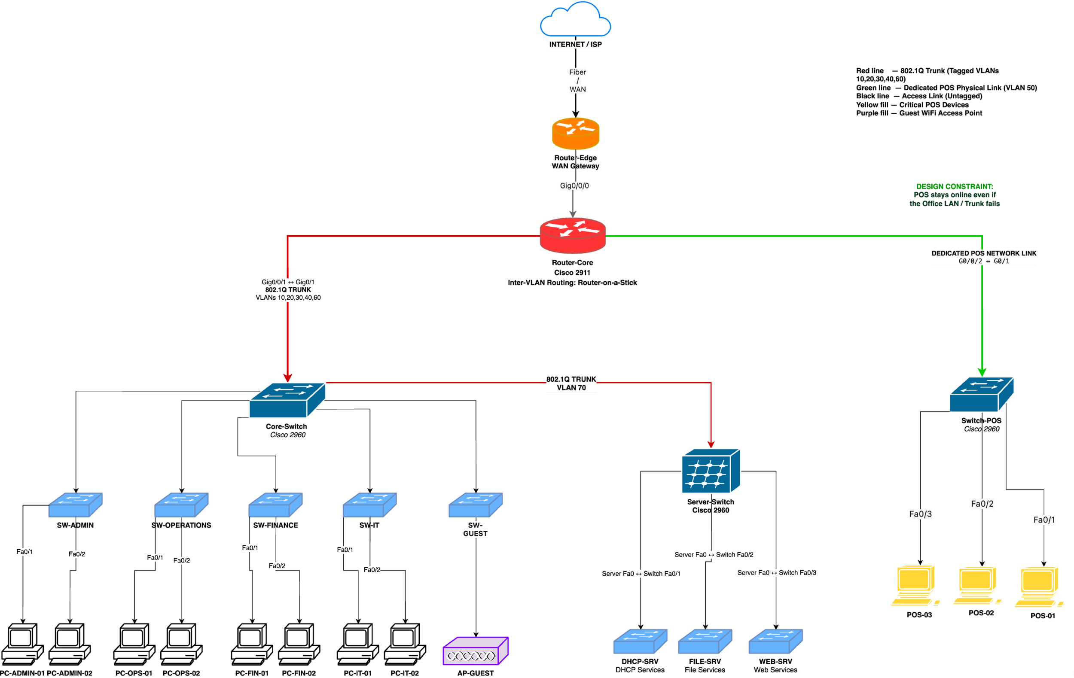
Motsweding Event Management — physical devices, cabling, and interface labelling. See Section 3 for full discussion.

Figure 2 — Proposed Logical Network Topology
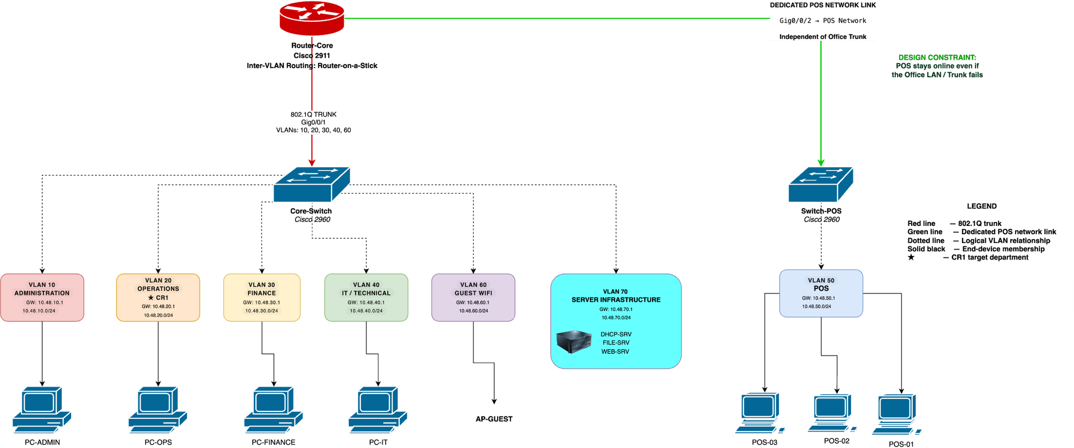
Motsweding Event Management — VLAN structure, Router-on-a-Stick relationships, and POS isolation. See Section 4 for full discussion.

5. IP Addressing Plan
The addressing plan uses the assigned 10.48.0.0/16 IPv4 block as its basis. The current design allocates a /24 subnet to each major segment — five office departments, POS, and servers — giving 254 usable host addresses per subnet. This is deliberately generous relative to current headcount: it provides substantial spare capacity in every VLAN, and in particular gives Operations (VLAN 20), the CR1 target department, more than enough room to add eight staff without any change to the subnet boundaries, gateway address, or VLAN structure.
VLAN | Segment | Network | Default Gateway | Usable Hosts | CR1
10 | Administration | 10.48.10.0/24 | 10.48.10.1 | 254 | Capacity available
20 | Operations | 10.48.20.0/24 | 10.48.20.1 | 254 | Target department
30 | Finance | 10.48.30.0/24 | 10.48.30.1 | 254 | Capacity available
40 | IT / Technical | 10.48.40.0/24 | 10.48.40.1 | 254 | Capacity available
50 | POS | 10.48.50.0/24 | 10.48.50.1 | 254 | Dedicated POS segment
60 | Guest Wi-Fi | 10.48.60.0/24 | 10.48.60.1 | 254 | Capacity available
70 | Server Infrastructure | 10.48.70.0/24 | 10.48.70.1 | 254 | Capacity available

5.1 Addressing Principles
The addressing scheme was designed to be simple, consistent, scalable, and easy to troubleshoot. The assigned 10.48.0.0/16 block provides sufficient address space for the segmented network.
The third octet of each subnet corresponds directly to the VLAN number. For example, VLAN 20 uses 10.48.20.0/24 and VLAN 70 uses 10.48.70.0/24. This creates a predictable relationship between VLAN identifiers and IP networks, making the addressing plan easier to interpret and troubleshoot.
Each /24 subnet provides 254 usable host addresses. The first usable address in each subnet is reserved as the default gateway. For example, VLAN 20 uses 10.48.20.1 as its default gateway, while VLAN 70 uses 10.48.70.1.
Infrastructure devices such as servers and network equipment can use appropriately assigned static addresses within their respective segments, while client addressing can be allocated from the remaining host range. The large capacity of each /24 subnet provides sufficient room for future growth.
For CR1, the Operations department uses VLAN 20 and the 10.48.20.0/24 subnet. The eight additional employees can therefore be assigned unused addresses within the existing subnet without changing the VLAN, subnet mask, or default gateway. This satisfies the scalability requirement without requiring a network redesign.

5.2 Router-on-a-Stick Logical Interfaces
Logical Interface | VLAN | Gateway | Purpose
G0/0/1.10 | 10 | 10.48.10.1/24 | Administration
G0/0/1.20 | 20 | 10.48.20.1/24 | Operations
G0/0/1.30 | 30 | 10.48.30.1/24 | Finance
G0/0/1.40 | 40 | 10.48.40.1/24 | IT / Technical
G0/0/1.60 | 60 | 10.48.60.1/24 | Guest Wi-Fi
G0/0/1.70 | 70 | 10.48.70.1/24 | Server Infrastructure
The listed sub-interfaces represent the logical Router-on-a-Stick design and will be configured on the trunk-facing interface of Router-Core during the Packet Tracer implementation. Each sub-interface is associated with an 802.1Q VLAN identifier and provides the default gateway for its corresponding subnet.
The exact physical interface naming will be verified against the selected Cisco Packet Tracer router model during implementation. VLAN 50 remains outside this main Router-on-a-Stick trunk because the POS environment uses its own dedicated physical connectivity in accordance with the client's resilience requirement.
VLAN 70 is included in the Router-on-a-Stick design because the Server-Switch is connected to the Core-Switch through a trunk carrying the server VLAN. This allows the server network to remain logically segmented while still participating in inter-VLAN routing through Router-Core.

6. Initial GitHub Repository
The project is maintained as an individual GitHub portfolio under the account Ofentse2212 in a repository dedicated specifically to the Motsweding Event Management network project.
Repository: https://github.com/Ofentse2212/motsweding-network-infrastructure
The repository is structured to document the development lifecycle of the network rather than only presenting the final result. The root README provides a professional overview of the project, its architecture, technologies, current status, and major design objectives.
The docs/ directory contains the client requirements and IP addressing documentation. The physical and logical topology diagrams are maintained as design evidence, while subsequent stages will add the Cisco Packet Tracer implementation, device configurations, verification results, screenshots, testing evidence, troubleshooting records, and the final .pkt file.
The repository will also document significant design decisions and changes made during development. This includes the introduction of the Core-Switch hierarchy, departmental access switches, the dedicated POS path, Guest Wi-Fi segmentation, and the proposed VLAN 70 server infrastructure. These additions will be explained in terms of their technical purpose rather than presented as requirements directly prescribed by the client brief.

6.1 Repository Development
Meaningful, incremental commits are used to demonstrate genuine development over time rather than a single bulk upload at the end of the project. Documentation is updated in step with the project itself: this Milestone 1 content reflects the design baseline, and further commits will layer on Packet Tracer implementation, testing, and final verification as those stages are completed ahead of Milestone 2 and the final submission.

6.2 Development, Troubleshooting and Design Evolution
The network design was developed incrementally from the client requirements rather than being treated as a fixed diagram from the beginning. Initial development focused on understanding the distinction between physical and logical topology and translating the client's requirements into a network architecture that could later be implemented in Cisco Packet Tracer.
One of the first challenges was distinguishing physical devices from logical network structures. In particular, VLANs initially required additional consideration because they represent logical broadcast domains rather than physical devices. This distinction was resolved by representing VLANs as logical segments in the logical topology while representing actual routers, switches, servers, PCs, access points, and physical connections in the physical topology.
Another challenge involved developing an appropriate switching hierarchy. The initial office-switch representation was refined after reviewing the requirement for a core switch to aggregate the departmental networks. The design was therefore expanded to include a Core-Switch with dedicated departmental access switches. This provides a clearer hierarchical structure and allows future devices to be added to the appropriate department without restructuring the entire network.
The POS availability requirement also influenced the architecture. Rather than placing the POS systems entirely on the same path as the office network, a dedicated POS switching path was retained. This provides a separate physical connectivity path and will later be tested in Cisco Packet Tracer to determine whether POS connectivity remains available when the main office path is isolated.
During the design process, additional supporting infrastructure was considered where it improved the realism and completeness of the proposed network. A dedicated Server Infrastructure VLAN (VLAN 70) was introduced to logically separate DHCP, file, and web services from ordinary user networks. This was a design decision made by the student and not a claim that these specific VLANs or server roles were explicitly prescribed by the brief.
The topology will continue to evolve during implementation. Any changes made during Packet Tracer configuration will be documented through GitHub commits and reflected in the relevant diagrams and addressing documentation so that the final implementation remains consistent with the documented design.

7. Milestone 1 Review Checklist
☑ Client requirements documented and aligned to the project brief.
☑ Physical topology completed and presented as Figure 1.
☑ Logical topology completed and presented as Figure 2.
☑ Departmental switching hierarchy represented through a Core-Switch and access switches.
☑ POS resilience represented through a dedicated physical path.
☑ Guest Wi-Fi represented as a separate logical VLAN.
☑ Server Infrastructure represented as VLAN 70 and documented as a student design decision.
☑ IP addressing plan documented using the assigned 10.48.0.0/16 block.
☑ VLAN 20 provides sufficient capacity for CR1's eight additional Operations staff.
☑ Router-on-a-Stick design documented for the routed VLANs.
☑ Initial GitHub repository established and maintained through incremental development.
☑ Design decisions and development challenges documented.

8. Design Notes for Subsequent Milestones
Milestone 1 establishes the design baseline, and subsequent implementation should remain consistent with it unless a documented design decision requires a change. Configuration, testing, troubleshooting, and evidence will be added to the GitHub repository as the Packet Tracer implementation progresses toward Milestone 2. In particular, the POS-availability design shown in Sections 3 and 4 is the proposed approach, not yet a proven result: it will be verified through targeted connectivity testing once the Packet Tracer build is complete — for example, by disabling or isolating the office LAN/trunk and confirming that POS devices remain reachable through their dedicated link — and the outcome of that test will be documented as evidence rather than assumed in advance.
During the implementation phase, the documented VLANs, IP addressing, trunk relationships, access ports, and Router-on-a-Stick sub-interfaces will be configured in Cisco Packet Tracer. The proposed design will then be tested against the client requirements. Particular attention will be given to inter-VLAN connectivity, VLAN 20 scalability for CR1, server accessibility, and the independent POS path. Any discrepancy between the design and implementation will be documented, investigated, and resolved rather than concealed.

9. Academic Integrity and Verification
The network implementation, configuration, testing, and submitted evidence remain the student's responsibility throughout. Any AI assistance used in preparing this documentation complies with the applicable NWU AI Policy, and does not transfer responsibility for the submitted work away from the student. All design decisions and Packet Tracer behaviour described in this document must be personally understood and independently verified before submission and before the video demonstration.

